Date: | Customer Name:
Phone: | Address:

Harness

Harness For Racing Only: | For Road Use:

F.I.A. Approved: | SFI Approved: | ECE R16 Approved:

Number of Harnesses Required: | Measurements in: | mm: inches:

Color - | Blue: | Red: | Black:

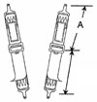  11” Standard Single Seater Type: | 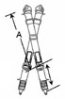  11” Standard Saloon Type: |  | Rotary (Aircraft) Buckle
 |  | 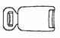 | Push Button
 |  | 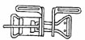 | Lever Latch & Link

Shoulder Straps

Webbing Width - | 75 mm (3”): | 50 mm (2”):

Length: | (measure distance “A” from center of anchor mounting tongue to center of adjuster)

Lap Straps

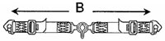 | Webbing Width - | 75 mm (3”): | 50 mm (2”):

Length: | (measure distance “B” from anchor point to anchor point)

Direction of Adjustment

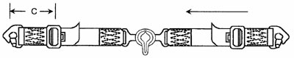 | Pull Up:
 | Length:
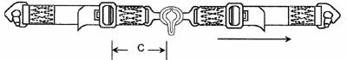 | Pull Down:
Crotch Strap

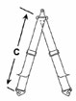 | 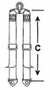 | 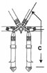 | Length:
 |  |  | (measure distance “C”)

Rotary Buckle Fixed To

Right Hand Lap Strap: |  | Left Hand Lap Strap:
 | Crotch Strap:

Anchorage

Open End  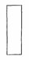 | Wrap Around  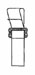 | Looped & Sewn  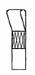  (please state loop diameter in inches) | Snap Hook  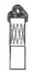 | Bolt Fixing Type A  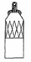  Please state hole diameter:  6mm (1/4)  8mm (5/16)  9mm (3/8) | Bolt Fixing Type B  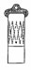  Please state hole diameter:  9mm (3/8)  11mm (7/16) | Pinch Plates  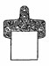
 |  |  |  |  |  |  | Shoulder Strap
 |  |  |  |  |  |  | Lap Strap
 |  |  |  |  |  |  | Crotch Strap

Anchorage

3 Bar Slider Adjuster  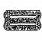 | Standard Willans 50mm (2”) Adjuster  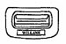 | Spring Loaded 50mm (2”) Adjuster  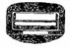 Shoulder Only | Aluminum Alloy 50mm (2”) Adjuster  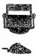 | 75mm (3”) Willans Steel Adjuster  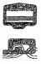 | 75mm (3”) Willans Aluminum Alloy Adjuster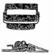 | Nylon ‘T’ Handles  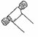 | Velcro  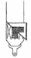
 |  |  |  |  |  |  |  | Shoulder Strap
 |  | Not Available |  |  |  |  |  | Lap Strap
 |  | Not Available |  |  |  |  |  | Crotch Strap

